1. Click on “Create Bucket”

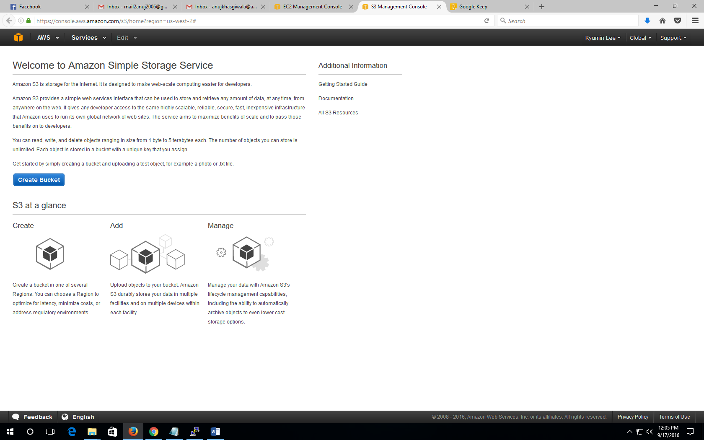

1. Give bucket name and click create.

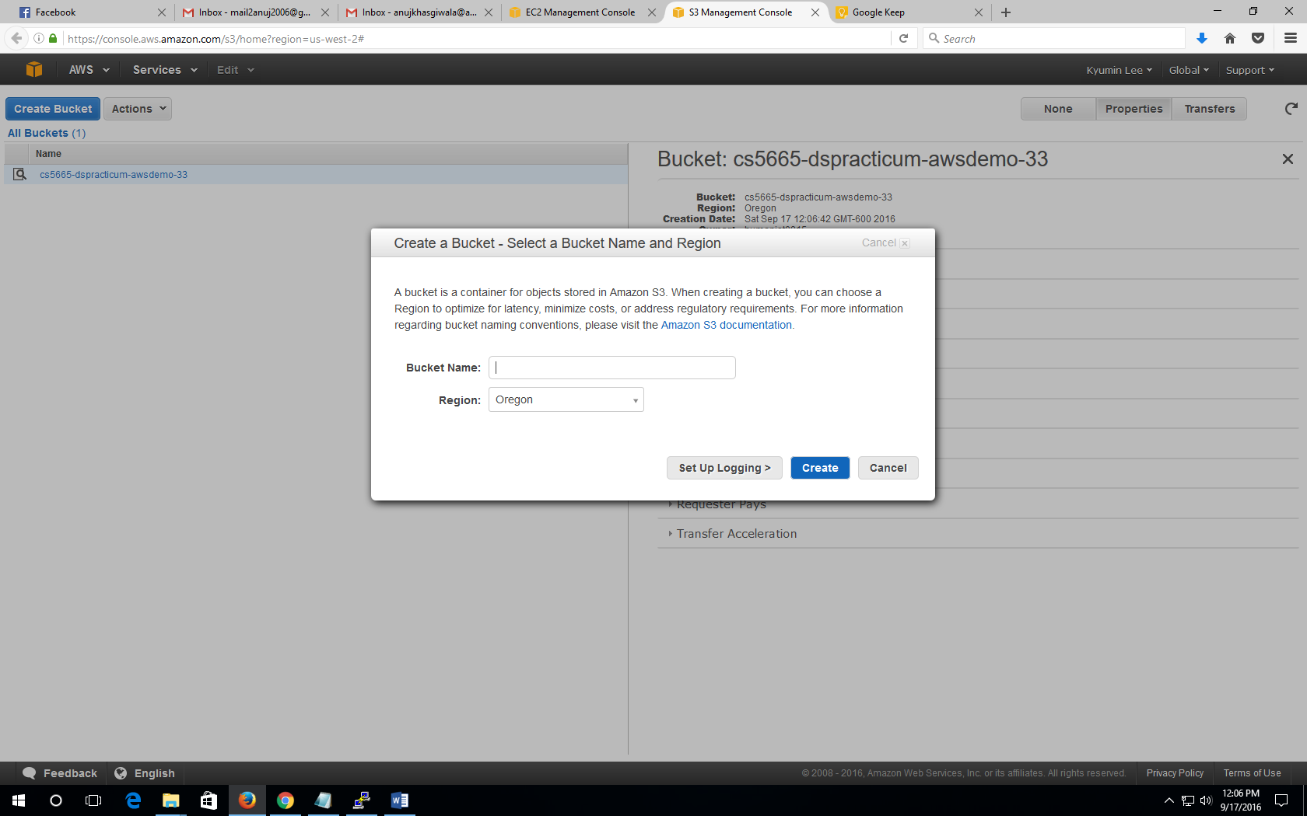

Reference:

http://docs.aws.amazon.com/AmazonS3/latest/gsg/CreatingABucket.html